1. Packages

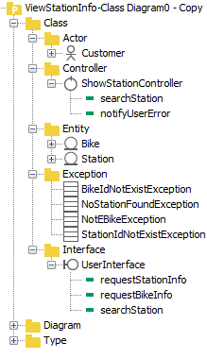

1. Class diagram
2. Class specification
3. Class Bike

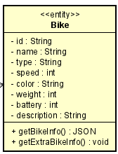

***Attributes:***

|  |  |  |  |  |
| --- | --- | --- | --- | --- |
| # | Name | Data Type | Default value | Description |
| 1 | id | String | Null | // |
| 2 | name | String | Null | // |
| 3 | type | String | Null | // |
| 4 | speed | int | Null | // |
| 5 | color | String | null | // |
| 6 | weight | int | Null | // |
| 7 | battery | String | Null | // |
| 8 | description | String | Null | // |

***Operations:***

|  |  |  |  |  |  |
| --- | --- | --- | --- | --- | --- |
| # | Name | Return Type | Description | Parameter | Exception |
| 1 | getBikeInfo | Json | get the bike attributes | null | null |
| 2 | getExtraBikeInfo | Json | get Ebike info, only work with Ebike | null | NotEBikeException-If bike is not Ebike |

***Method:***

None

***State:***

None

1. Class Station

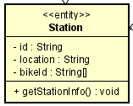

***Attributes:***

|  |  |  |  |  |
| --- | --- | --- | --- | --- |
| # | Name | Data Type | Default value | Description |
| 1 | stationId | String | Null | // |
| 2 | loaction | String | Null | // |
| 3 | bikeId | String [] | Null | List of bikeId in the station |

***Operations:***

|  |  |  |  |  |  |
| --- | --- | --- | --- | --- | --- |
| # | Name | Return Type | Description | Parameter | Exception |
| 1 | getStationInfo | Json | Get Station Info, including station id, location and its bike basic info | null | null |

***Method:***

None

***State:***

None

1. Class UserInterface

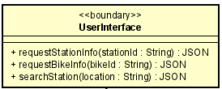

***Attributes:***

None

***Operations:***

|  |  |  |  |  |  |
| --- | --- | --- | --- | --- | --- |
| # | Name | Return Type | Description | Parameter | Exception |
| 1 | requestStationInfo | Json | // | stationId | StationIdNotExistException |
| 2 | requestBikeInfo | Json | The Bike is determined through station | bikeId | BikeIdNotExistException |
| 3 | searchStation | Json | Search station through user inputed location | location | NoStationFoundException |

***Method:***

None

***State:***

None

1. Class ShowStationController

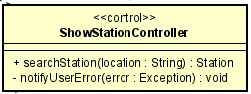

***Attributes:***

|  |  |  |  |  |
| --- | --- | --- | --- | --- |
| # | Name | Data Type | Default value | Description |

***Operations:***

|  |  |  |  |  |  |
| --- | --- | --- | --- | --- | --- |
| # | Name | Return Type | Description | Parameter | Exception |
| 1 | searchStation | Station | Search the station through user input info | location | NoStationFoundException |

***Method:***

|  |  |  |  |  |  |
| --- | --- | --- | --- | --- | --- |
| # | Name | Return Type | Description | Parameter | Exception |
| 1 | notifyUserError | void | Notify the user if there is an error occur | error | null |

***State:***

None